CHAPTER 8
Comparative Advantage and the Gains from International Trade
- Chapter Summary
- Learning Objectives
- Chapter Outline
Teaching Tips/Topics for Discussion
- Solved Problem
- Solutions to Review Questions and Problems and Applications

1. Chapter Summary
Over the past 50 years international trade has grown significantly. Many governments have reduced tariffs and have entered into agreements to reduce trade barriers with other nations. International trade has grown because it makes people better off. Comparative advantage proves that people from two different nations will be made better off trading those goods and services which each can produce at a lower opportunity cost. A person, firm, or nation with an absolute advantage in producing a good or service can produce more of the good or service than competitors when using the same amount of resources. The producer has a comparative advantage in producing a good or service if the producer has a lower opportunity cost than a competitor has.
With international trade nations specialize in the production of the products they export. However, complete specialization is unlikely because of the following reasons: (1) not all goods and services are traded internationally; (2) as more exported goods are produced the opportunity costs of producing additional units eventually increase; and (3) most products are differentiated; therefore, some buyers in the United States (for example) will prefer to purchase domestically produced automobiles while other buyers will prefer automobiles produced by firms from Japan or Germany.
Not all firms and their workers will benefit from international trade. The revenues and profits of domestic firms that produce the same goods that are also imported will fall and some of the firms’ workers may lose their jobs. Those harmed by trade often lobby their governments to impose import restrictions.
Nations develop comparative advantages for different reasons, including: a favorable climate and the availability natural resources; an abundance of supplies of labor or capital; access to superior production technologies; and external economies.
Despite the gains from free trade, nations impose trade restrictions that result in higher prices for traded goods. Trade restrictions usually are in the form of tariffs, quotas and voluntary export restraints, and non-tariff barriers. Tariffs are taxes imposed by governments on imports. A quota is a numerical limit on the quantity of a good that can be imported. A voluntary export restraint is an agreement between two countries to place a numerical limit on the quantity of a good that can be imported. Although tariffs and quotas will save jobs in the countries that impose them the employment gains often are achieved at a very high cost.
After World War II the United States and Europe made attempts to reach agreements to reduce the high tariff rates imposed during the Great Depression. A series of multilateral negotiations among nations had reduced tariffs and expanded international trade. Recent negotiations have focused on expanding trade in services and products incorporating intellectual property. The World Trade Organization (WTO) was established in 1995 to facilitate these negotiations.
Opposition to liberalization of international trade and investment (“globalization”) grew in the 1990s. Supporters of the anti-globalization movement want to protect domestic industries from competition and believe globalization unfairly favors the interests of high-income countries.
The North American Free Trade Agreement (NAFTA) eliminated most tariffs among the United States, Mexico and Canada when it went into effect in 1994. Although some people in all three countries were made worse off by NAFTA, most economists have concluded that NAFTA has helped the U.S. economy become more efficient.
The United States government has extended protection to some domestic industries due to allegations of “dumping” by foreign companies. Dumping refers to selling a product for a price below its cost of production. Charges of dumping are controversial since selling at prices below costs is a normal business practice of many companies in their home markets.
Multinational enterprises conduct operations in more than one nation for five main reasons: (1) to avoid tariffs on exports; (2) to gain access to raw materials available in other nations; (3) to gain access to low-cost labor; (4) to minimize foreign exchange risk; and (5) to respond to competition from other firms in their industry.

2. Learning Objectives
Students should be able to:
- Discuss the increasing importance of international trade to the United States.
- Understand the difference between comparative advantage and absolute advantage.
- Explain how countries gain from international trade.
- Discuss the sources of comparative advantage
- Analyze the economic effects of government policies that restrict international trade.
- Evaluate the arguments for and against government policies that restrict international trade.

3. Chapter Outline
Sugar Quota Drives U.S. Candy Manufacturers Overseas
1. The United States Congress enacted a quota on the importation of sugar in order to preserve jobs in the domestic sugar industry. The quota resulted higher sugar prices for consumers, including firms that use sugar as an input to produce other products.
►Teaching tips: Ask students to describe the impact of sugar quotas on consumers of chocolate, cereal and other products that use sugar as in input in production. This chapter-opening scenario can be assigned along with An Inside Look at the end of the chapter. The questions posed following An Inside Look can be used as the basis for classroom discussion or examination questions.
An Overview of International Trade
1. Imports are goods and services bought domestically but produced in other countries.
2 A tariff is a tax imposed by a government on imports.
3 Exports are goods and services produced domestically but sold to other countries.
4. Outsourcing occurs when a domestic firm uses workers in a foreign country to produce a good or service that is then sold to domestic consumers.
►Teaching tips: Initiate a class discussion based on Making the Connection 6-1. If students have already formed opinions about the impact of outsourcing, these opinions are likely to be negative and based on conversations with relatives and friends and anecdotal evidence from the media. Encourage students to base their opinions on facts (positive economic analysis).
Comparative Advantage: The Basis of All Trade
1. Comparative advantage is the ability of an individual, business, or country to produce a good or service at the lowest opportunity cost.
2. Mutually beneficial trade between two parties is possible when they specialize in the production of the goods and services for which they have a comparative advantage and trade for the goods and services for which they have comparative disadvantage in production. Comparative advantage is the basic argument in favor of free trade, both domestic and international.
►Teaching tips: Remind students that comparative advantage was defined and explained in chapter 2. Ask students to review Solved Problem 2-2 from this chapter as well as the example of comparative advantage illustrated in Table 6-1.
The Gains from Trade
1. The gains from trade can be illustrated with an example of two counties that produce the same two goods under conditions of autarky. Autarky is a situation where a country does not trade with other countries.
- When each country specializes in the production of the good for which it is has a comparative advantage, and trades some of this good for the some of good produced by the other country: (a) total production of both goods can be greater than it would be under conditions of autarky and (b) total consumption of both goods in both countries can be greater with trade than under conditions of autarky.
- The terms of trade is the ratio at which a country can trade its exports for imports from other countries.
2. Although countries as a whole are better off trading, firms and workers in industries that produce goods for which they have a comparative disadvantage (higher opportunity cost) can be harmed by trade.
►Teaching tips: Solved Problem 6-1 describes the gains from trade based on David Ricardo’s famous cloth and wine example. Instructors need to decide whether to use class time to review this example or to assign it to students as a reading or homework assignment. In either case, it is important that students understand the explanation of the gains from trade and the meaning of absolute and comparative advantage.
Where Does Comparative Advantage Come From?
1. Comparative advantage results from several sources:
- Climate and natural resources.
- Relative abundance of labor and capital.
- Technology.
- External economies.
►Teaching tips: Raymond Vernon provided a classic example of the importance of external economies. Anyone who lives in or has visited New York City, Manhattan in particular, knows that prices for most goods and services are higher there than in other cities. Real estate and transportation is expensive, streets are crowded and employees must be paid a premium to work there to compensate for the high cost of living. Yet, the garment and financial industries located in Manhattan continue to thrive despite these disadvantages. For both of these industries ready access to suppliers, customers and competitors are important assets. Personal contacts and face-to-face meetings are critical to the success of doing business. The large market size and concentration of related businesses offered by New York City are more important assets than the lower cost of real estate and transportation offered by locations outside of Manhattan.
Government Policies that Restrict Trade
1. Free trade refers to trade between countries that is free from government restrictions. Free trade policies offer benefits to consumers of imported goods and allows for a more efficient allocation of resources than is possible under conditions of autarky or international trade that is restricted by tariffs or other trade barriers.
2. Free trade also harms firms that are less efficient than their foreign competitors.
- A quota is a numerical limit imposed by the government on the quantity of a good that can be imported into a country
- A voluntary export restraint is an agreement negotiated between two countries that places a numerical limit on the quantity of a good that can be imported by one country from the other country.
- In addition to tariffs, quotas and voluntary export restraints, governments sometimes erect other barriers to trade, such as health and safety requirements and national security restrictions.
►Teaching tips: Figures 6-7 and 6-8 illustrate the deadweight losses that result from the imposition of a tariff or quota. But students may be more responsive to the estimates of the per-job cost to consumers of saving jobs in industries protected by trade restrictions. Review the estimates of these costs as listed in Tables 6-5 and 6-6 (part of Solved Problem 6-2). Those who favor restrictions on international trade must be willing to argue that these costs are justified.
The Argument over Trade Policies and Globalization
1. Debates over the merits of free trade and policies to restrict trade date back to the beginning of the United States. After World War II government officials from United States and Europe sought to establish an international agreement to reduce trade barriers and promote free trade.
2 Opposition to free trade policies, often referred to as “globalization,” among some interest groups occurred in the 1990s. This opposition was based on the fear that low-income countries were at risk of losing their cultural identity as multinational countries sold Western goods in their markets and relocated factories in their countries to take advantage of low-cost labor.
►Teaching tips: Arguments for and against free trade and globalization offer excellent opportunities to encourage students to analyze important policy issues in an objective manner. Students will have formed opinions about these issues before taking this course. Many will be appalled at reports of low wages and poor working conditions offered by multinational corporations in developing countries. Students should be encouraged to form their own opinions, but these opinions should not be based on anecdotal evidence. Making the Connection 6-3 offers a powerful description of the alternatives available to workers in countries where there are opportunities for employment with multinational firms.
3. Dumping refers to selling a product for a price below the cost of production, a practice that has been used by the United States government to justify the imposition of tariffs on some imported foreign goods. Although allowable under the WTO agreement, using tariffs to offset the effects of dumping is very controversial.
►Teaching tips: It is difficult to distinguish firms that have used dumping in a predatory manner (that is, to harm international competitors) from those that engaged in normal business practices. In both cases the result is lower prices for consumers. If the topic is discussed in the classroom or used for evaluation purposes, instructors can emphasize the similarity between arguments for and against dumping with arguments for and against tariffs and other trade restrictions.

4. Solved Problems
Chapter 6 in the textbook includes two Solved Problems to support learning objectives 3 (Explain how countries gain from international trade) and 5 (Analyze the economic effects of government policies that restrict international trade). Here are additional Solved Problems that support this chapter’s four other learning objectives.

Solved Problem 6-3: Supports Learning Objective 6-1: Discuss the increasing importance of international trade to the United States.

U.S. Jobs Supported by Exports of Manufactures

Figures 6-1 through 6-3 in the textbook describe the significance of international trade to the economies of the United States and several other countries. The following data provide additional evidence of the importance of exports to manufacturing employment in the United States. The industries listed are ranked by the percentage of exported – related jobs as a percentage of all jobs in the industry. (Jobs are in thousands. Data are for 1997.)

All Manufacturing Jobs from Export-Related Jobs
Jobs Exports as % of total
Industry Title
Total, All Manufacturing Industries 16,887.0 3,343.9 19.8
1. Computers and electronic products 1,698.5 602.7 35.5
2. Primary Metals 611.7 214.1 35.0
3. Machinery 1,421.8 396.5 27.9
4. Electrical equipment, appliances 594.9 153.7 25.8
& parts
5. Transportation equipment 1,848.6 469.5 25.4
6. Chemicals 884.3 220.9 25.0
7. Fabricated Metal Products 1,774.9 391.8 22.1
8. Textile mills 393.9 82.0 20.8
9. Leather and allied products 84.8 16.4 19.3
10. Plastics and rubber products 1,030.0 177.1 17.2

- What do these employment statistics suggest about the ability of these manufacturing industries to compete in world markets?
- Can one argue that the Untied States did not import any goods from these ten manufacturing industries in 1997?

Solving the Problem:
Step 1: Review the chapter material. This problem is about exports of U.S. manufacturing industries, so you may want to review the section “An Overview of International Trade,” which begins on page 164 of the textbook.
Step 2: Answer question (a). Suggest reasons why the ten industries were able to create jobs through exports. The United States had a comparative advantage in the production of these goods relative to the nations that imported goods from these industries. The opportunity cost of obtaining goods from these industries via imports from the Untied States was less than opportunity cost of producing them at home.
Step 3: Answer question (b). One cannot assume that the U.S. did not import goods produced in the same industries in which it has also exported. This is true for two reasons. First, the industry classifications listed are broad; many different goods are produced by different firms within Primary Metals, Machinery and the other industries. Some of these goods may be imported and some may be exported. Second, the United States trades with many nations. Although it may have a comparative advantage in the production of a manufactured good with respect to one country, it may have a comparative disadvantage in the production of a similar version of the same good with another country. For example, the U.S. may export Ford Taurus cars to one country and import Subaru Outbacks from Japan.

Source: International Trade Administration, “U.S. Jobs from Exports,” February 2001.

Solved Problem 6-4: Supports Learning Objective 6-2: Understand the difference between comparative advantage and absolute advantage.

Confusion over the Basis for Trade

Historian Paul Kennedy of Yale University wrote the following regarding comparative and absolute advantage:
[H]ow does [modernization] work when production of an item takes place not just in a specific region…but globally when there are 50 countries, with varying standards of wages, capable of producing soybeans, and 70 countries capable of producing steel?
Adam Smith’s famous argument in favor of free trade and specialization (that it made no economic sense for both England and Portugal to strive to produce wine and textiles when England’s climate made it a better textile producer and Portugal’s climate made it a better wine producer) doesn’t address this reality of multiple competitive sources. Yet, that is the basis of modern, free-market economics. What if there is nothing you can produce more cheaply or efficiently than anywhere except by constantly cutting labor costs?

(a) Professor Kennedy explains that a well-known argument for free trade between England and
Portugal was based on (I) England’s favorable climate for producing textiles and (II) Portugal’s favorable climate for producing wine. Is the argument for trade based on absolute advantage or comparative advantage?
- Is it true that for some nations “…there is nothing you can produce more cheaply or efficiently than anywhere….”?

Solving the Problem:
Step 1: Review the chapter material. This problem is about comparative advantage and absolute advantage, so you may want to review the section “Comparative Advantage: The Basis of All Trade,” which begins on page 167 of the textbook.
Step 2: Is the argument for trade based on absolute or comparative advantage? The argument for free trade is based on comparative advantage. In effect, Professor Kennedy statements regarding the climates of England and Portugal are claims that each has an absolute advantage: textiles for England, wine for Portugal.
Step 3: Is it true that for some nations there is nothing they can product more cheaply than other nations? No. Even if a nation has an absolute disadvantage in two goods versus another nation it will have a comparative advantage in one of them, if the opportunity cost of producing each good differs for the two countries.

P.S. It was David Ricardo, not Adam Smith, who used the wine-cloth example of comparative advantage as an argument in favor of free trade.

Solved Problem 6-5
Supports Learning Objective 4: Discuss the sources of comparative advantage

Solved Problem 6-3 Revisited

The success the firms in the industries listed in Solved Problem 6-3 have achieved in exporting suggests that the United States has a comparative advantage in the production of goods produced by these firms. What is the likely source, or sources, of this comparative advantage?

Solving the Problem:
Step 1: Review the chapter material. This problem is about the sources of comparative advantage, so you may want to review the section “Where Does Comparative Advantage Come From?” which begins on page 173 of the textbook.
Step 2: Identify the main sources of comparative advantage. These are: an advantageous climate and abundant supplies of natural resources; relatively abundant supplies of labor and capital; technology; and external economies.
Step 3: Identify the likely sources of comparative advantage for the industries listed in Solved Problem 6-3. These are all manufacturing industries so the source would not be climate or abundant supplies of resources. Although unskilled labor is more costly in the United States than in most other countries, the supply of skilled labor (for example, managers, engineers, and technicians) is relatively abundant. Some manufacturing industries have a comparative advantage in developing and implementing new technology. These are the two most likely sources of the comparative advantage of firms in these industries.

Solved Problem 6-6 Supports Learning Objective 6: Evaluate the arguments for and against government policies that restrict international trade.

Sunlight! Bah, Humbug!

Arguments over international trade are nothing new. Alexander Hamilton called for the protection of so-called “infant industries” in the United States and farming interests have long espoused trade restrictions to prevent consumers from buying cheaper food products from abroad. Although the countries and industries change over time the arguments over trade restrictions have not. The 19th century French economist, Frédèric Bastiat, satirized French opponents of free trade in writing a petition to the French government supposedly from the manufacturers of “candles, waxlights, lamps, candlesticks, street lamps…generally of everything connected with lighting:” Bastiat’s “petition” has been reprinted many times and often appears in textbooks because of its clever theme as well as its applicability to the arguments of 21st century “petitioners.”

We are suffering from the intolerable competition of a foreign rival, placed, it would seem, in a condition so superior to ours for the production of light that he absolutely inundates our national market with it at a price fabulously reduced. The moment he shows himself, our trade leaves us – all consumers apply to him; and a branch of native industry, having countless ramifications, is all at once rendered completely stagnant. This rival…is no other than the sun…
What we pray for is, that it may please you to pass a law ordering the shutting up of all windows, skylights, dormer-windows, outside and inside shutters, curtains, blinds…all openings, holes, chinks, clefts, and fissures by or through which the light of the sun has been in use to enter houses, to the prejudice of the meritorious manufacturers with which we flatter ourselves we have accommodated our country – a country which, in gratitude, ought not to abandon us now to strife to unequal.

Source: Frédèric Bastiat, Social Fallacies, translated by Patrick James Stirling, Santa Anna, CA: Reigister Publishing, 1944, pp. 60-61.

What are the arguments used today for trade restrictions?

Solving the Problem:
Step 1: Review the chapter material. This problem is about debates over free trade, so you may want to review the section “The Argument over Trade Policies and Globalization,” which begins on page 182 of the textbook.
Step 2: Cite arguments from chapter 6 that are similar to those raised in Bastiat’s petition. In describing protectionism Hubbard and O’Brien write:
For as long as international trade has existed, governments have attempted to restrict it to protect domestic firms…protectionism causes losses to consumers and eliminates jobs in domestic industries that use the protected product…Supporters of protectionism argue that free trade reduces employment by driving domestic firms out of business…jobs are (indeed) lost, but jobs are also lost when more-efficient domestic firms drive less-efficient domestic firms out of business…No economic study has ever found a connection in the long run between the total number of jobs available and the level of tariff protection for domestic industries.
Source: pages 252-253.

As Bastiat might have said: “plus ça change, plus c’est la même chose.” (“The more things change, the more they stay the same.”)

CHAPTER 6 Appendix
Multinational Firms

Multinational Firms
1. Multinational enterprises are firms that conduct operations in more than one country.
- Two innovations made it possible for firms to coordinate operations on several continents.
  - The first was the completion of the transatlantic cable in 1866 which made possible instant communication by telegraph between the United States and Europe.
  - The second was the development of more efficient steam engines which reduced the cost and increased the speed of long ocean voyages.
- Foreign direct investment is the purchase or building by a domestic firm of a facility is a foreign country.
- Foreign portfolio investment is the purchase by an individual or firm of stocks or bonds issued in another country.
- In the early twentieth century most U.S. firms expanded abroad through foreign direct investment because the stock and bond markets in other countries were often too poorly developed to make foreign portfolio investment practical.
2. Today most large U.S. corporations have established facilities overseas because they expect to increase their profitability by doing so.
- Firms might expect to increase their profits though overseas operations for five reasons.
  - To avoid tariffs or the threat of tariffs
  - To gain access to raw materials
  - To gain access to low-cost labor
  - To minimize exchange-rate risk
  - To respond to industry competition
- Most newly established U.S. firms begin by selling only in the United States. If successful they will begin to export, using foreign firms to market and distribute their products.
- If firms’ exporting efforts are successful they will establish their own overseas marketing and distribution networks.
- Finally, the firms will establish their own production facilities in foreign countries.
3. Firms face costs from expanding into foreign markets that differ from the costs of operating in domestic markets.
- Tastes differ between consumers in foreign and domestic markets.
- Employment practices differ between foreign and domestic markets.
4. U.S. firms possess certain competitive advantages when operating in foreign countries.
- Some firms, such as Coco-Cola and McDonald’s, have strong name recognition.
- Some firms possess a significant technological edge over foreign rivals.
- Some firms have developed efficient, low-cost ways production methods.
- Some firms, for example, Intel, have proven to be better at designing and rapidly bringing to market new products than their foreign competitors.
►Teaching tips: Many people believe that when U.S. firms locate production facilities in other countries the level of employment and wages in the U.S. decline. Making the Connection 6A-1 explains that wages of U.S. workers are determined by their productivity. Competition from low-wage workers in other countries has little impact on the wages of U.S. workers. Since the U.S. economy produces about 2 million jobs annually workers who lose jobs at one firm, whether due to foreign competition or some other factor, can eventually find jobs at other firms.

5. Solutions to Review Questions and Problems and Applications

Answers to Thinking Critically Questions

1. These import quotas allow some workers in these industries to keep their jobs. However, there is a high cost. The quotas don’t increase the total number of jobs in the economy and the cost per current job saved can be very high in some industries, as Table 6-5 shows. Quotas in the sugar industry cause losses to consumers that are more than twice the size of the gains to producers, as shown in Figure 6-8. Protecting jobs in one industry can also cause job losses in another industry, as when the sugar quota results in U.S. candy companies relocating to other countries. Unless you have a personal economic stake in the sugar, beef or dairy industry, you will probably lose from the protection of these workers’ jobs.

2. The U.S. has a comparative advantage in the production of computers, electronic gizmos, farm produce, movies, and software. We know this because the United States exports these goods to Australia. Australia must have a comparative advantage in the production of beef, dairy products and sugar. It exports these to the U.S.

Answers to Review Questions

1. While the U.S. is the world’s leading exporter, as shown in Figure 6-3 exports and imports as a share of total output (GDP) are smaller for the U.S. than for most other industrialized countries. Because the U.S. has a large and diverse economy, the gains from trading with other economies probably aren’t as great as they would be if the U.S. were smaller and less diversified, like Belgium or South Korea.

2. Comparative advantage is the ability of an individual, business, or country to produce a good or service at the lowest opportunity cost. It is powerful because it focuses on opportunity cost and is the basis of theories that show the immense gains – to rich and poor alike – that can be generated from trading.

3. Absolute advantage is the ability to produce more of a good or service than competitors using the same amount of resources. Comparative advantage is the ability to produce a good or service at a lower opportunity cost than other producers. A country will often import goods in which it has an absolute advantage. For example, the U.S. could produce textiles with fewer resources than in China, but China produces these goods for the U.S. allowing it to produce other goods that are even more valuable.

4. International trade increases a country’s consumption because it allows it to specialize in the goods and services which it can produce at the lowest opportunity cost and trade for goods and services for which it has a higher opportunity cost.

5. Complete specialization would mean producing only one good. It is not typical for a country to completely specialize because not all goods and service are traded internationally, the production of most goods involves increasing opportunity costs, tastes for products differ so different countries may have comparative advantages in different varieties of the same good, and because the talents of people (and other resources) within a country differ.

6. The main sources of comparative advantage include climate and natural resources, the relative abundance of various types of labor and capital, technology and know-how, and external economies – reductions in a firm’s costs that result from an expansion in the size of the industry.

7. A tariff is a tax imposed by the government on imports. A quota is a numerical limit imposed by the government on the quantity of a good that can be imported. Non-tariff barriers include governmental rules – for example health or safety regulations – that favor domestic firms over foreign firms.

8. The winners from tariffs are domestic producers and the government. The losers are domestic consumers. The winners from quotas are domestic producers and whoever holds the import license. The losers, again, are domestic consumers.

9. The collapse of world trade during the Great Depression and the desire to create a stable, prosperous world economy after World War II, led to the General Agreement on Tariffs and Trade. The WTO eventually replaced GATT when it was felt that a permanent international organization would do a more effective job at expanding international trade and working out agreements on trade in services and intellectual property rights.

10. Globalization is the process of countries becoming more open to foreign trade and investment. Some people oppose it because they believe it will make them worse off or will harm other people they care about – especially poor workers in developing countries.

11. Protectionism is the use of trade barriers to shield domestic companies and their workers from foreign competition. The beneficiaries are the protected domestic companies and their workers. The losers are domestic consumers and other domestic producers who cannot buy their inputs as cheaply. The main arguments for protectionism are that it saves jobs and protects high wages, that it allows “infant” industries a chance to get started and grow, and that it protects national security. It is important to weigh the benefits of each of these against the costs.

12. Dumping is selling a product for a price below its cost of production. The losers from dumping are competitors of the firm that dumps (and the dumping firm itself if it is selling below its marginal cost). Consumers are the beneficiaries. The biggest problems in implementing anti-dumping laws are that it is difficult to measure firms’ costs, so it is difficult to know if they are dumping. Also, there are often good reasons for selling goods below the average total cost of production. Domestic firms do this, so it is unclear why foreign firm should not.

Answers to End-of-Chapter Problems and Applications

1. The goods that countries import and export change over time because the goods in which they have a comparative advantage change over time.

2. Japan had a comparative advantage in producing these goods, even though it did not have an absolute advantage.

3. a. Chile has an absolute advantage in the production of both hats and beer.
b. Chile has a comparative advantage in the production of hats, and Argentina has a comparative advantage in the production of beer. Chile’s opportunity cost of producing one hat is three-fourths of a unit of beer, but Argentina’s opportunity cost of producing one hat is 2 units of beer. Thus, Chile’s opportunity cost is lower and it has the comparative advantage in hat production.
c. Chile should specialize in producing hats, and Argentina should specialize in producing beer. By specializing, Chile can produce 8,000 hats per hour, and Argentina can produce 2,000 barrels of beer per hour. If Chile trades 600 hats to Argentina for 600 barrels of beer, the countries will end up with:

 | Hats | Beer
Chile | 7,400 | 600
Argentina | 600 | 1,400

Both countries are better off than they were before specializing and engaging in trade.

4. The opportunity cost of producing one good is the amount of the other good that has to be given up. To produce one cell phone, Japan has to give up 0.5 MP3 players. To produce one MP3 player, Japan has to give up two cell phones. To produce one cell phone, the United States has to give up two MP3 players. To produce one MP3 player, the United States has to give up 0.5 cell phones.

5. As explained in the text, this statement is correct. Production of most goods and services involves increasing opportunity costs.

6. By trading this way with the Chinese, Americans aren’t “surrendering” the more efficient industries. These industries aren’t more efficient; they produce their goods at a higher opportunity cost than in China. By moving resources out of these industries, the U.S. can do even better – freeing up these resources to produce the goods in which it has the comparative advantage and using this output to trade for goods that can be produced at a lower opportunity cost elsewhere. A country increases its income by specializing in products where it has a comparative advantage, even if this means giving up production of products where it has an absolute advantage, but not a comparative advantage.

7. Free trade probably benefits smaller countries more because without trade it would be difficult for producers in these countries to benefit from external economies and economies of scale. Also, larger more populous countries are likely to have a wider range of people with a wider range of comparative advantages, so they can gain significantly from trading among themselves, but this is less likely in smaller countries.

8. “Protectionist demands” refers to the use of tariffs, quotas and non-tariff barriers to protect domestic industries. Unilateral free trade would benefit American consumers because they could buy some goods more cheaply than before. In fact, it would benefit all the countries involved by allowing America’s overseas trading partners to specialize more in the goods and services in which they have the lowest opportunity cost and to trade them for goods that the U.S. can produce at a lower opportunity cost.

9. In this context, economic nationalism refers to using tariffs, quotas and non-tariff barriers to protect domestic industries. As explained in the text, a country benefits from free trade even if other countries do not engage in it. It gains because it can obtain goods and services at a lower opportunity cost via trading.

10. The commentator is confusing absolute advantage and comparative advantage. Every country, no matter how poor, will have a comparative advantage is producing some good. (Often countries are poor because they cannot or will not trade with others.)

11. A movie studio in Southern California can take advantage of the availability of skilled workers, the opportunity to interact with other movie studios, and being close to suppliers. Economists refer to these advantages as external economies.

12. a.

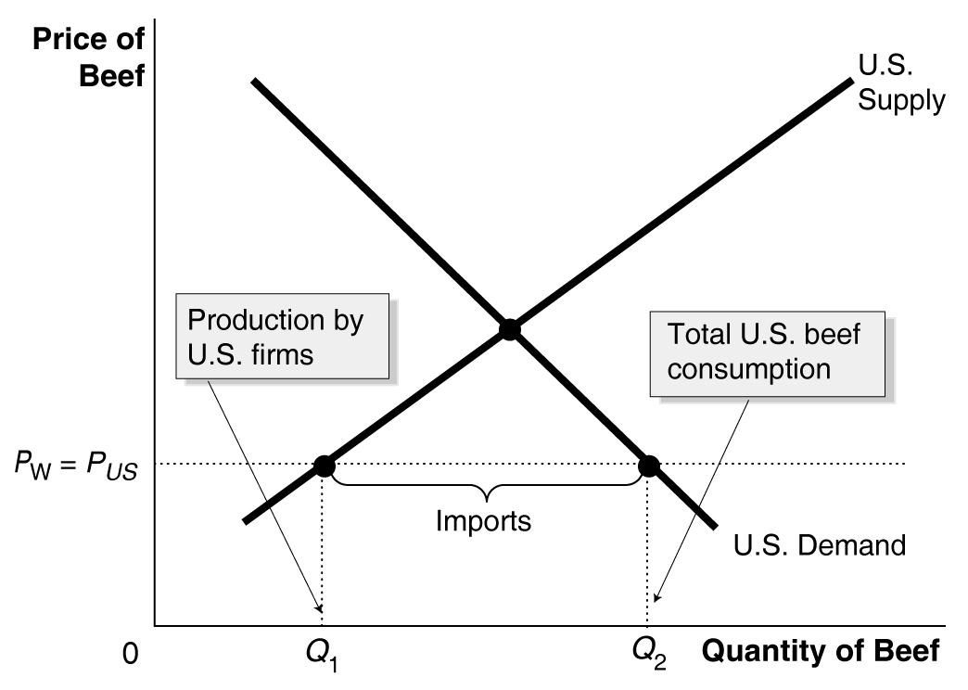

12. b.

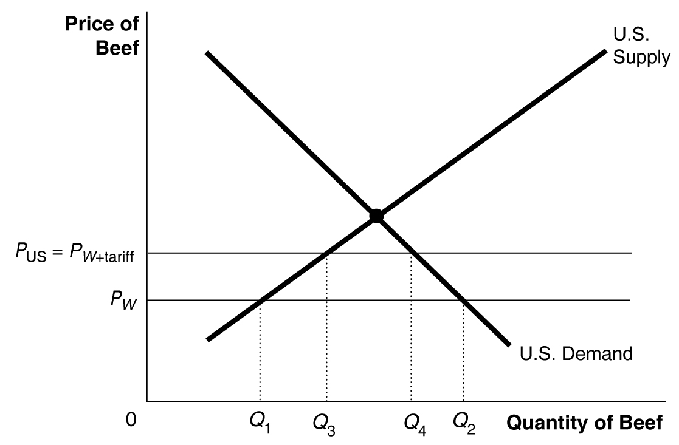

Before the tariff, the quantity of beef sold by U.S. producers is Q₁; after the tariff, the quantity of beef sold by U.S. producers is Q₃. Before the tariff, the quantity of beef imported = Q₂ – Q₁; after the tariff, the quantity of beef imported = Q₄ – Q₃.

12. c. The winners from the tariff are domestic producers of beef and the government, which collects the tariff revenue. The losers are domestic consumers of beef.

13. Clinton was probably referring to minimum wage laws, the rights to form unions, and laws to protect the health and safety of workers. The governments of most developing countries have resisted these proposals. They argue that when the currently rich countries were poor, they lacked these types of labor standards, and their workers received low wages. They argue that it is easier for rich countries to afford high wages and other labor protections than it is for poor countries. They also point out that many jobs that seem very poorly paid and unsafe by industrial country standards are often better than the alternatives available to workers in developing countries.

14. Those industries that use sugar in their products will be hurt by the sugar quota. Producers of artificial sweeteners and other substitutes for sugar (like corn syrup) will be helped by the sugar quota because it raises the price of sugar.

15. Consumers pay more than domestic producers receive, because some of the benefits are captured by foreign producers. In addition, consumers bear the cost of the deadweight loss that a quota imposes on the economy. A “straight handout” would be a direct payment by the government to the firms that would otherwise receive protection through a quota. It would be cheaper because it would avoid making consumers pay for the gains received by foreign producers and for the deadweight loss that represents the economic inefficiency a quota imposes on the economy.

16. These subsidies allow European farmers to sell sugar for a lower price than they otherwise would. This pushes down the world price for sugar and allows European producers to retain part of the sugar market they would otherwise lose to South African and other foreign producers of sugar.

17. A quota on steel imports raises the costs of producing goods that use steel. This causes the prices of these goods to rise, thereby reducing the quantity sold. Heavy steel users, such as the automobile industry, and those exporting goods made with steel would be most affected.

18. The student’s reasoning is flawed. The prices charged by U.S. producers will rise by as much or more if foreign competition is entirely eliminated. With a tariff the price in the U.S. will be P_{US} instead of the world price, P_{W}. If imports are banned altogether the price in the U.S. will rise to P_{NT}, the no-trade price. Also, if the imported goods are a different style or quality than the U.S. goods, U.S. consumers will face a reduced variety of goods.

19. When the U.S. government puts a tariff on steel imports, it protects steelworkers in West Virginia at the expense of steelworkers in South Korea (and elsewhere). Landsburg is making a normative statement. Redborn is also making a normative statement.

20. Economists usually measure the standard of living by the goods and services that the typical person in a country is able to purchase. In this case, the Chinese government will have reduced the standard of living of its own people and raised the standard of living of people in the United States. The standard of living in the U.S. is raised because U.S. consumers are able to purchase Chinese goods at a price below their true cost of production. The standard of living in China is reduced because the government has used some of the country’s resources to cover the cost of goods that are sent to the United States. Subsidizing exports is almost like giving money to foreign consumers.

21. The statement is probably a correct assessment of U.S. public opinion. Public opinion is probably not as well informed as you will be after studying economics, which will allow you to more competently weigh the costs and benefits of free trade.

22. Trade allows a country to specialize in producing the goods in which it has a comparative advantage. After trading, the country can consume more. In this sense it can “produce more with less” and consumers win. See Table 6-4 for a good example of trade leading to gains for consumers.

23. The sugar quota helps domestic sugar growers by increasing the price of their product. It harms sugar refineries because the total amount of sugar to be refined (domestic production plus imports) is lower. It harms candy manufacturers and other food manufacturers because they must pay more for their inputs and can’t compete as well with foreign suppliers who can buy sugar more cheaply. It hurts consumers, who must pay more for sugar and goods with sugar in them. It hurts farmers in developing countries because they can’t export as much to the U.S. market.

24. While society as a whole benefits, not everyone wins from expanding international trade. Some domestic suppliers and their workers lose if they are driven out of the market (and into new markets) by lower-priced imports.

25.
 | Without Quota | With Quota
World price of kumquats | $0.75 | $0.75
U.S. price of kumquats | $0.75 | $1.00
Quantity supplied by U.S. firms | 4 million | 6 million
Quantity demanded | 13 million | 12 million
Quantity imported | 9 million | 6 million
Area of consumer surplus | A + B + C + D + E +F | A + B
Area of domestic producer surplus | G | C + G
Area of deadweight loss | 0 | D + F

Answers to Appendix Review Questions

1. Large U.S. corporations first began to operate internationally in the late 1800s, as the transatlantic cable made intercontinental communications easier and steam power reduced the cost and speed of long ocean voyages.

2. Foreign direct investment is the purchase or building by a domestic firm of a facility in a foreign country. Foreign portfolio investment is the purchase by an individual or firm of stocks or bonds issued in another country. Because Toyota is a Japanese firm, its ownership of an assembly plant in the U.S. is an example of foreign direct investment.

3. The ultimate reason firms expand overseas is because they think doing so will increase their profits. The main reasons for overseas expansions are 1) to avoid tariffs or the threat of tariffs, 2) to gain access to raw materials, 3) to gain access to low-cost labor, 4) to minimize exchange risk, and 5) to respond to industry competition. U.S.-based oil companies have extensive overseas operations because it gives them much greater access to the raw materials they use.

4. Among the major reasons for the success of U.S. firms overseas are the strength of their brand name products and their technological edge over foreign competitors.

Answers to Appendix Problems and Applications

1. In 1850 it would have been difficult to operate internationally (though some firms did so successfully) because of limited communication and transportation capabilities.

2. Both automobiles and farm machinery were assembled using unskilled labor. U.S. labor costs were the highest in the world, so assembling these products overseas gave the firms access to low-cost labor. In addition, both products are expensive to ship, so manufacturing overseas would reduce these costs and operating overseas would avoid tariff barriers. Also, overseas consumers probably would be more willing and able to purchase products manufactured in their own countries.

3. Smaller investment is often required and there is often less risk in buying an existing firm with a locally-recognized brand name in an overseas market, rather than building new facilities there.

4. A U.S. firm might produce at a higher cost in another country if this allowed the firm to avoid tariffs or if it feared future tariffs or other trade restrictions. Also, foreign consumers probably would be more willing and able to purchase the firm’s product if it is manufactured in their country.

5. In some ways expanding internationally is similar to expanding within the U.S. Many of the same managerial decisions must be made. However, international expansion often brings in added complications due to language, cultural and legal differences, exchange rate risk, and potential trade restrictions.

6. In some ways expanding internationally is similar to expanding into a new product market. Expanding into a new product market requires learning about new technologies and the tastes and preferences of consumers in a new area. International expansion also requires learning about the tastes and preferences of new consumers, but the existing technology can often be applied in the new market. Among the key differences are that international expansion often brings added complications due to language, cultural and legal differences, and potential trade restrictions, while expanding a product line rarely brings these complications.

7. Such firms have been successful in the U.S., so they often first expand into countries in which consumers and conditions are like those in the U.S. – countries with high average incomes, those with similar legal environments, and English-speaking (or Spanish-speaking) countries. They are also likely to expand into countries where they can gain access to raw materials and gain access to low-cost labor.

